Patron
Pro Vice Chancellor, Vellore Institute of Technology (VIT), Chennai
Convenor
Dr. S. Harshavarthini, Department of Mathematics, School of Advanced Sciences (SAS), VIT, Chennai
Co-Convenor
Dr. N. Ramesh Babu, Department of Mathematics, SAS, VIT, Chennai
Organizing Secretary
Prof. S. Mahalakshmi, Dean, SAS, VIT, Chennai

ADDRESS FOR CORRESPONDENCE:

Dr. S. Harshavarthini & Dr. N. Ramesh Babu
Assistant Professors, Department of Mathematics,
SAS, VIT Chennai,
Vandalur - Kelambakkam Road,

Chennai - 600127.
Tamil Nadu, India.
Mobile: +91 8110818304; +91 8778097050
Email: harshavarthini.s@vit.ac.in; n.rameshbabu@vit.ac.in

REGISTRATION FEE: NIL

Limited participants only.

ACCOMMODATION
Accommodation will be arranged for participants on prior request either at the university guest house or at the nearby hotels reachable from the venue.

OBJECTIVES OF THE WORKSHOP

- Explore recent advancements at the intersection of Quantum Computing and Artificial Intelligence, particularly in the development and application of Quantum Neural Networks (QNNs).
- Foster a deeper understanding of the theoretical and computational aspects of Quantum AI while encouraging discussions and collaborations between early-career researchers and leading experts in the field.
- Introduce fundamental and advanced concepts of quantum algorithms, quantum machine learning, and hybrid quantum-classical models to address computational challenges in AI.
- Equip participants with essential knowledge on quantum-enhanced optimization, stochastic processes in quantum systems, and the implications of quantum entanglement in neural networks.
- Highlight practical applications of Quantum AI in industry, scientific research, and real-world problem-solving, preparing professionals to tackle highly complex computational issues.
INVITED SPEAKERS (Tentative)
International Delegates
Dr. Sangmoon Lee, Professor,
School of Electronics Engineering,
Kyungpook National University, South korea.
Dr. Kurunathan Ratnavelu, Professor,
Institute of Mathematical Sciences,
Department of Physics,
UCSI University, Malaysia.
Dr. C. P. Lim, Professor,
Research Programmes Lead (Defence),
Swinburne University of Technology,
Australia.
Dr. O. M. Kwon, Professor,
School of Electrical Engineering,
Chungbuk National University, Sounth Korea.
Dr. JinRong Wang, Professor,
Department of Mathematics,
Guizhou University, China.
Dr. Dhafer Almakhles, Associate Professor,
Department of Communications and Networks
Engineering, Prince Sultan University,
Saudi Arabia.

National Delegates
Dr. K. Murugesan, Professor,
Department of Mathematics,
National Institute of Technology,
Tiruchirappalli.
Dr. Manil T. Mohan, Associate Professor,
Department of Mathematics,
Indian Institute of Technology, Roorkee.
Dr. R. Sakthivel, Professor,
Department of Applied Mathematics,
Bharathiar University, Coimbatore.
Dr. P. Balasubramaniam, Professor,
Department of Mathematics,
The Gandhigram Rural Institute (DTBU),
Dindigul.
Dr. Muslim Malik, Associate Professor,
School of Basic Sciences,
Indian Institute of Technology, Mandi.
Dr. V. Govindaraj, Assistant Professor,
Department of Mathematics,
National Institute of Technology, Puducherry.

TO REGISTER

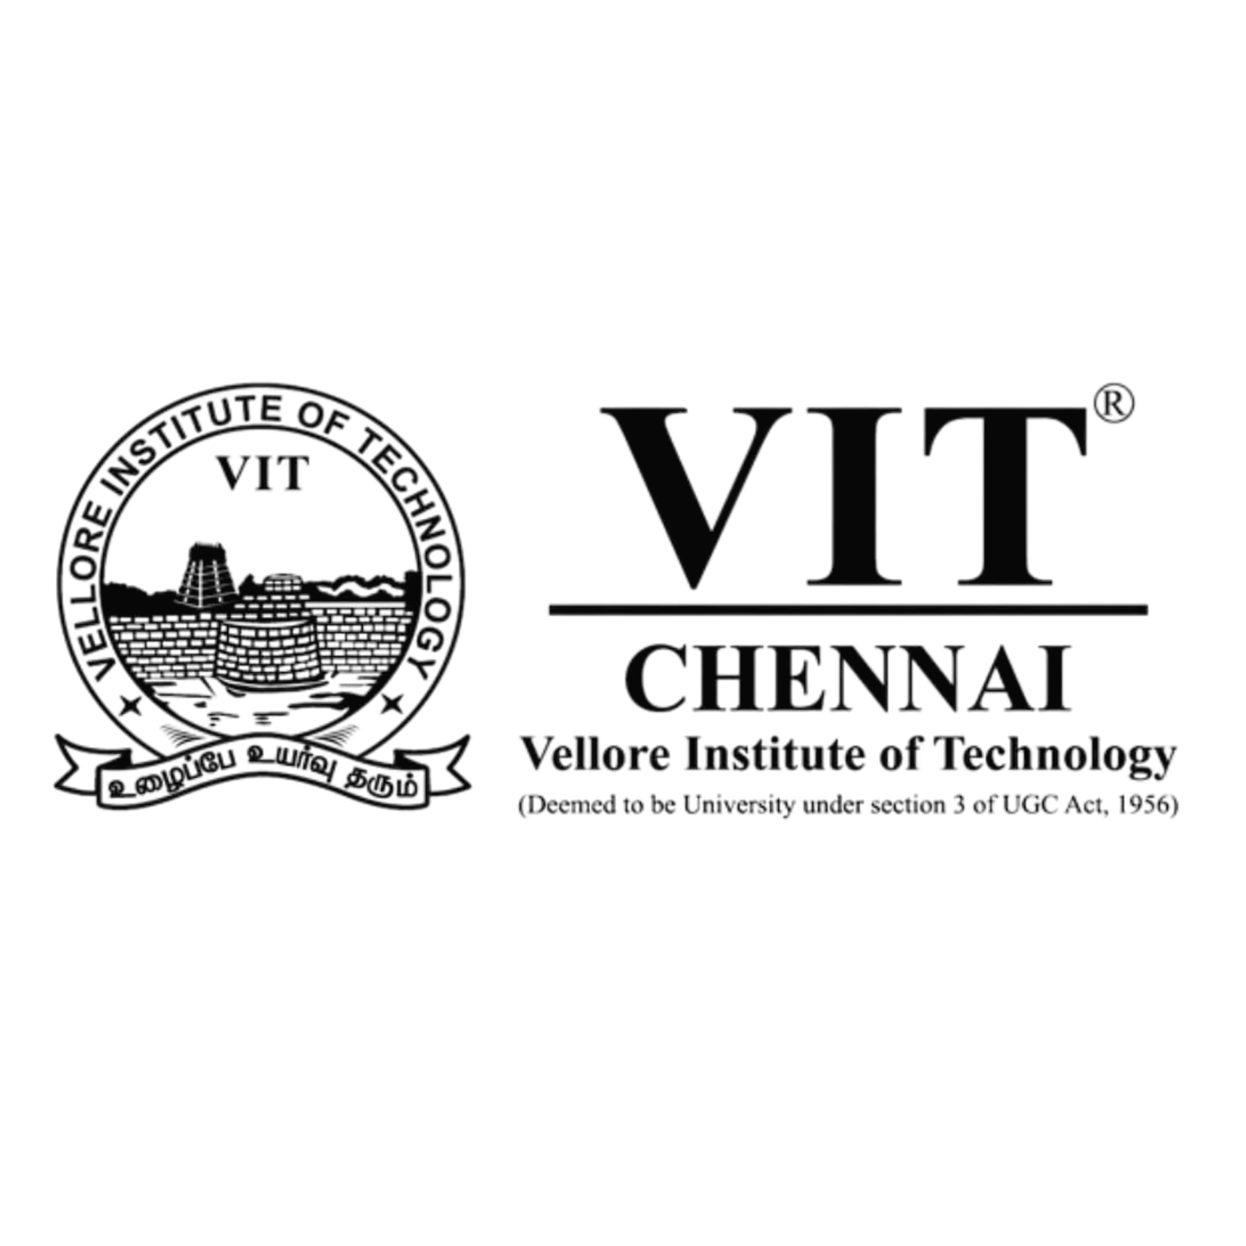
VELLORE INSTITUTE OF TECHNOLOGY (VIT)
Founded in 1984, VIT has made a mark in the field of higher education in India imparting quality education intertwined with extensive application-oriented research in a multi-cultural ambience. VIT aims to provide quality higher education on par with institutes of International Standards. It persistently seeks and adopts innovative methods to improve the quality of higher education on a consistent basis. VIT was established by the well-known educationalist and former parliamentarian, honorable Dr. G. Viswanathan, the Founder and Chancellor, a visionary who transformed VIT into a Centre of Excellence in higher technical education. The MHRD, Government of India ranked VIT the 8th Best University, the 11th Best Research Institution and the 11th Best Engineering Institution in India (NIRF Ranking, Govt. of India 2024). As per QS World University Rankings by Subject 2024, Engineering and Technology subject areas of VIT are the 163th Best in the Asia and the 21th Best in Southern Asia.

ABOUT THE SCHOOL

The School of Advanced Sciences (SAS) at VIT includes Department of Mathematics, Physics, and Chemistry. It offers Ph.D and M.Sc program in these disciplines. The faculty of the school comprises qualified and goal-oriented members whose research expertise includes major frontier areas in Mathematics, Physics and Chemistry.

ABOUT VIT CHENNAI

VIT Chennai is a globally engaged, competitive, comprehensive and research-enriched campus strategically positioned in the capital city of Tamil Nadu, to respond to major industrial, social, economic and environmental demands and challenges. VIT Chennai is ably spearheaded by Vice Presidents Mr. Sankar Viswanathan, Dr. Sekar Viswanathan, Mr. G.V. Selvam, Assistant Vice President Ms. Kadhambari S. Viswanathan, Vice Chancellor Dr. Rambabu Kodali, and Pro Vice Chancellor Dr. V.S. Kanchana Bhaaskaran.
They share in the mission to make VIT a global centre. The focus is:

- To maximize the Industrial Connectivity
- To create centres of Excellence in niche areas of research
- To enrich technological and Managerial Human Capital nurtured in a multicultural ambience
- To provide a common platform for the agglomeration of ideas of personnel from various walks of life for learning
- To create opportunities and exploit the available resources to benefit industry/society
- To encourage participation in the National Agenda of knowledge building
- To foster international collaborations for mutual benefits in areas of research.

TARGET AUDIENCE

This Workshop is mainly intended for mathematicians, engineers, scientists, research scholars, academicians, postgraduate and undergraduate students.
International Workshop on Quantum Mathematics and Imaging for Smart Manufacturing and Industry 4.0
(QMI-2025)

15th – 19th December 2025
Venue: AB1-201(Conference hall)
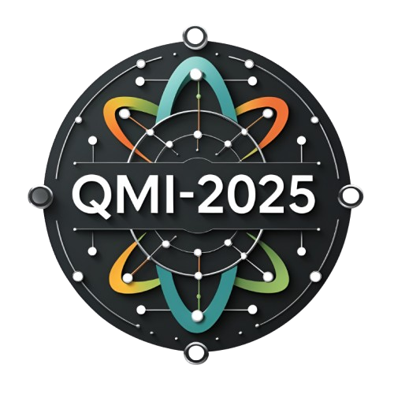

Organized by

Department of Mathematics

School of Advanced Sciences (SAS)
Vellore Institute of Technology (VIT) Chennai – 600127
Tamil Nadu, India

VIT - A place to learn; A chance to grow

